Cottage Hospital 1st Annual Any Which Way 5k Sponsorship Levels:

$1,500 Platinum Sponsor:
- Sponsorship for post event lunch
- Large size logo on event T shirt (company logo must be provided by August 1, 2021)
- Large size logo on race banner (displayed in prominent town location prior and at event, logo must be provided by August 1, 2021)
- All sponsorship benefits listed below (Gold, Silver, Bronze and Honorable Mention)
$750 Gold Sponsor:
- Corporate banner displayed at event (must be provided by September 1, 2021)
- Small size logo on event T shirt (company logo must be provided by August 1, 2021)
- Sponsorship recognition with all radio advertising
- 2 complimentary race entries for USAT&F sanctioned 5K
- All sponsorship benefits listed below (Silver, Bronze and Honorable Mention)
$500 Silver Sponsor:
- Logo on race markers
- Logo and link on website and Facebook
- Complimentary pre-race and post-race expo table
- All sponsorship benefits listed below (Bronze and Honorable Mention)
$250 Bronze Sponsor:
- Logo on event marketing posters
- Logo on brochure and entry forms
- 2 free boxed lunches at event
- Sponsorship benefits listed under Honorable Mention
Under $100 Honorable Mention Sponsor:
- Sponsor name listed on “Thank You” banner at finish line
- Sponsor name listed on “Thank You” print ads
- RECOGNITION FOR BEING A PARTNER IN THE HEALTH OF OUR COMMUNITY

Other items: Sponsors are encouraged to donate items to the race day “swag bags” (promo items or company information). We are expecting 200 participants, materials should be provided to Cottage Hospital by September 1, 2021. Please call for questions or additional details.

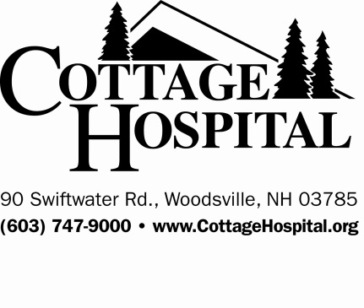
Expo Table: Set up time is 730am. $100 fee (waived for Silver and above sponsors). Table and chairs are provided (deadline for expo space reservation is September 1, 2021).

Sponsorship Commitment Form must be received by 8/1/2021.
Cottage Hospital 1st Annual Any Which Way 5k Sponsorship Form

Sponsor Name (as it will appear in Print) _________________________________________________________
Address ____________________________________________________________________________________
Contact Person _________________________Phone ___________________Email _______________________
Authorized Signature _________________________________________________________________________
We plan to donate the following “in kind” items: __________________________________________________
“In-Kind” Value _____________________________________________________________________________

Sponsorship Amount $ ___________
Expo Table Amount $ ___________
Total Sponsorship $ ___________

Payment Method:
- Contact me for Credit Card Payment
- Check Enclosed
- Bill Me

Please return sponsorship form to:
Cottage Hospital Community Relations Department
Attn: Dhaniele Duffy
90 Swiftwater Road Woodsville, NH 03785

Any questions, please feel free to contact me at 603.747.9707 or at dduffy@cottagehospital.org
Please make check payable to: Cottage Hospital with Any Which Way 5k in Memo Field
RETURN BY AUGUST 1, 2021

